Abstract
The purpose of this to produce efficient numerical methods with the same order of accuracy as that of the main starting values for exact solutions of fourth order differential equation without reducing it to a system of first order differential equations. The methods of the differential systems arising from the approximate solution to the problem are adopted using the Runge-Kutta method and stages. The methods were compared and contrasted based on the results obtained. The comparison shows that Euler method gives accurate approximate result than Runge-Kutta method. After the derivation of the formulae of O(h2), the comparison was done in regards to identify the formula with higher accuracy.
Euler-Cromer Method
Simple modification of Eqs. (5), (4) yields solutions that are stable for oscillatory systems. Such Euler-Cromer algorithm or last-point approximation leads to the following difference equations
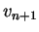 |  | 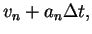 | (6)
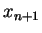 |  | 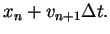 | (7)

As pointed out by Cromer in: A. Cromer, Stable solutions using the Euler Approximation, American Journal of Physics, 49, 455 (1981), this simple modification conserves energy for oscillatory problems (unlike Euler method which artifactually increases energy of the oscillator with time).
Midpoint and Half-Step Methods
Perhaps the most obvious way to improve the Euler method is to use the mean velocity during the interval to obtain the new position. The corresponding midpoint method can be written as
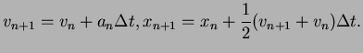 |  |  | (8)

Note that if substitute Eq. (8) for into Eq. (8), we obtain
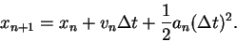 | (9)

Hence, the midpoint method yields second-order accuracy for the position and first-order accuracy for the velocity. Although the midpoint approximation yields exact results for constant acceleration, it usually does not yield much better results than the Euler method. In fact, both methods are equally poor, because the error increases with each time step.
A higher-order method whose error is bounded is the half-step method. In this method the average velocity during an interval is taken to be the velocity in the middle of the interval. The half-step method can be written as
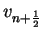 |  | 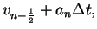 | (10)
 |  | 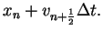 | (11)

Note that the half-step method is not self-starting, i.e., Eq. (10) does not allow us to calculate . The problem can be overcome by adopting the Euler algorithm for the first half step:
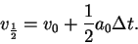 | (12)

Euler-Richardson Method
As can be seen from the proceeding discussion, the algorithm for obtaining a numerical solution of a differential equation is not unique, and there are many algorithms that reduce to the same differential equation in the limit . It might occur that it would be better to compute the velocity at the middle of the interval, rather that at the beginning or at the end of the interval. The Euler-Richardson algorithm is fusion of this idea together with the simple Euler method. This algorithm is particularly useful for velocity-dependent forces, but does as well as other simple algorithms for forces that do not depend on the velocity. The algorithm consists of using the Euler method to find the intermediate position 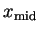 and the velocity 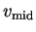 at the time 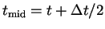. Then we compute the force, 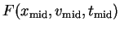, and the acceleration 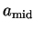 at 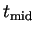. The new position and velocity at time 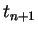 is found using and . We summarize the Euler-Richardson algorithm as follows:
 |  | 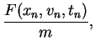 | (13)
 |  | 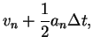 | (14)
 |  | 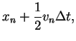 | (15)
 |  | 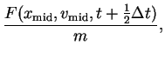 | (16)

so that the particle velocity and position are obtained from
 |  | 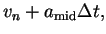 | (17)
 |  | 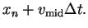 | (18)

Even though we need to do twice as many computations per time step, the Euler-Richardson algorithm is much faster because we can make the time step larger and still obtain better accuracy that with either the Euler or Euler-Cromer algorithm. Formal justification of the Euler-Richardson algorithm can be obtained, as usual, from the appropriate Taylor series expansion.
Verlet Method
One of the most common drift-free higher-order algorithms is commonly attributed to Verlet [L. Verlet, Computer experiments on classical fluids. I. Thermodynamical properties of Lennard-Jones molecules, Physical Review 159, 98 (1967); in this paper he discusses the method and its application to molecular dynamics simulations].We write the Taylor series expansion for 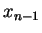 in a form similar to Eq. (3)
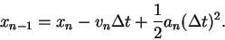 | (19)

If we add the forward and reverse forms, Eq. (3) and Eq. (19) respectively, we obtain
(20)

or
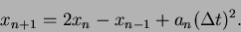 | (21)

Similarly, the subtraction of the Taylor series for and yields
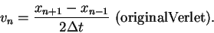 | (22)

Thus, the global error associated with the Verlet algorithm is third order for the position and second-order for the velocity. However, the velocity plays no part in the integration of the equations of motions. In the numerical analysis literature, the Verlet method is also knows as the ``explicit central difference method''.
Because the Verlet algorithm is not self-starting, another algorithm must be used to obtain the first few terms. An additional problem is that the new velocity Eq. (22) found by computing the difference between two quantities of the same order of magnitude. When using computers which always operate with finite numerical precision, such an operation results in a loss of numerical precision and may give rise to substantial roundoff error.
A mathematically equivalent version of the original Verlet algorithm is given by
 |  | 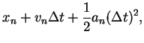 | (23)
 |  | 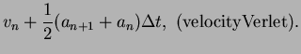 | (24)

We see that these equations, known as the velocity form of the Verlet algorithm, is self-starting and minimizes roundoff errors. We can derive Eqs. (23), (24) from Eqs. (21), (22) by the following considerations. We first solve Eq. (22) for and write 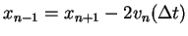. If we substitute this expression for into Eq. (21) and solve for , we find the form Eq. (23). Then we use Eq. (22) to write as
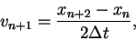 | (25)

and use Eq. (21) to obtain 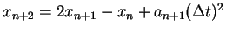. If we substitute this form for 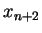 into Eq. (25), we obtain
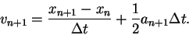 | (26)

Finally, we use Eq. (23) for to eliminate 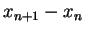 from Eq. (26); after some algebra we obtain the desired result Eq. (24).
Another useful algorithm that avoids the roundoff error of the original Verlet algorithm is due to Beeman and Schofield. We write the Beeman algorithm in the form
 |  | 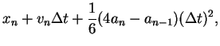 | (27)
 |  | 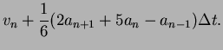 | (28)

Note that this algorithm does not calculate particle trajectories more accurately than the Verlet algorithm. Its advantage is that in general does a better job of maintaining energy conservation. However, the Beeman algorithm is not self-starting.
Conclusions
Generally, the aim of a good numerical differentiation is that such methods should give better approximations to the true differentials. By the examples above, it shows that the two methods produced better degrees of accuracy for ordinary differential equations of all orders. But comparing the percentage errors, we discovered that Standard Euler method is more accurate than Modified Euler and Runge-Kutta methods for the examples illustrated.
The exact solutions for both Euler and Runge-Kutta methods, whose values have the same order of accuracy with the derived solutions, were not only formulated, also tested for simplicity, efficiency and accuracy. We can conclude from the derivations above that the Standard Euler’s method has a higher degree of accuracy than the Modified Euler’s method, conclusion also supported by other studies It is remarkable therefore to note that all the examples illustrated are differential equations of order four and orders which are less than four.

Reference
Endre SMayer D. F., An introduction to Numerical Analysis, Cambridge University Press, 2003.
Hussain K., Ismail F., Senua N., Solving Direct Special First-Ordinary Differential Equations using Runge-Kutta, Journal of Computational and Applied Mathematics, 2016, p. 179-199.
Lanlege D. I., Garba U. M., Aluebho A., Using Modified Euler Method (MEM) for The solution of some First Order Differential Equations with Initial Value Problems (IVPs), Pacific Journal of Science and Technology, 2015, p. 63-81.
Leonarhd Euler., Standard Euler method: Available at: http://www.mathe.tufreiberg.de/~ernst/Lehre/Numerik_II/Folien/nadeChapter2.pdf (accessed 16/05/2017)
Bakhalou N. S., Numerical Methods, Mr. Publishing Company Inc., 1977.
Dormand J. R., Prince P. J., A reconsideration of some embedded Runge-Kutta Formulae, Journal of Computational and Applied Mathematics, 1986, 15, p. 203-211.
Hamming R. W., Numerical Methods for Scientists and Engineers, 2nd Edition, McGraw Hills Book, 1973.
http://www.physics.udel.edu/

